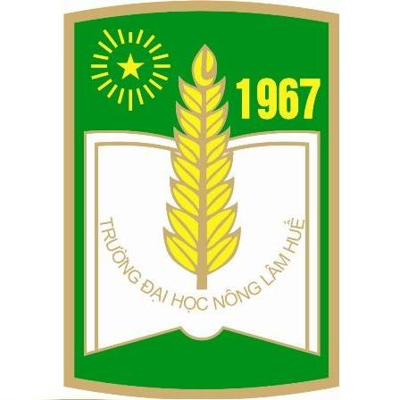

HUE UNIVERSITY
UNIVERSITY OF AGRICULTURE AND FORESTRY

CERTIFICATE OF ACHIVEMENT

RECTOR OF UNIVERSITY OF AGRICULTURE AND FORESTRY
CERTIFIES THAT:

Mister: Tick Nouanthavong
Date of birth: 15 – 7 – 1980
Place of birth: Xiengkhouang, Lao PDR
Major of study: Animal sciences
Enrollment year: 2017
Type: Full-time

has completed the doctoral study program and successfully defended her dissertation.

Thua Thien Hue, April 23th 2021
RECTOR

Assoc.Prof.Dr. Tran Thanh Duc

